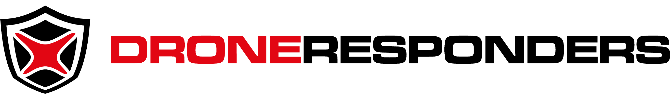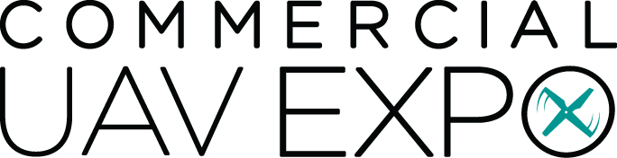

[DATE]

Dear [ADDRESSEE],

I respectfully request funding to attend the DRONERESPONDERS Public Safety Summit at Commercial UAV Expo in Las Vegas, Nevada from September 5-7, 2023.

This summit will unite public safety programs managers and operators of unmanned aircraft systems (UAS) from across the U.S. for two days of educational workshops and technology presentations that will help our agency develop a safer, more effective drone program to serve the public good.

In addition to the public safety UAS training and visibility our program will receive, I will have access to meet with solutions providers of the latest UAS technology on one of the largest exhibit floors in the unmanned systems industry. This will ensure our department has direct access to manufacturers and developers of the technology we use.

The full price of the Public Safety Summit with full exhibit access is $315 if procured prior to September 5 ($350 thereafter). Additional projected travel costs are outlined below:

Summit/Conference Pass:
Airfare:
Ground Transportation:
Hotels:
Meals:
TOTAL FUNDING REQUEST:

Additional information on the DRONERESPONDERS 2023 Public Safety Summit is available via http://summit.droneresponders.org

I thank you for your consideration of this training request to help ensure our department has one of the safest, most effective UAS programs in the nation.

Very Respectfully,

[Requestor Name, Title]

